10/06/25
Key concepts:
- Inference – metrics : latency – usually measured as time from image being input to model to its output. Ways of measuring .
- Methods for speeding up inference – quantization
Auxillary measurements – time it takes to move data from CPU to GPU
- Comparing different GPU models, some more optimized for batch offline
- Batching inference – can parallelize examples on different layers of the model, using specialized kernel functions to optimize calculations
- Quantization techniques – reduced precision while maintaining high accuracy. Used in post training usually, for model compresison
- Real time requirements – for real time applications
- Profilers – CUDA API's
- TensorRT - transforms model into real time engine for realtime applications

NVIDIA TensorRT is an SDK for deep learning inference.¹
Using it, you can deploy a deep learning application onto a GPU, for optimizing inference, specifically on latency and throughput metrics, doing so through powerful optimizations, use of reduced precision, and efficient memory use.
What it does, is it takes a deep learning model and, after converting it into ONNX format (format that is compatible with different deep learning frameworks), it creates a network object on the TensorRT software, that in turn generates a deep learning engine that is optimized for the target platform.
One optimization it provides is that given the optimum input, minimum and maximum tensor dimensions, it selects the kernel that results in the lowest runtime for the given profile.
It supports CUDA asynchronous inference, in which inputs are copied from CPU to GPU, and since it works asynchronously it allows for overlapping of GPU computer, which generally improves inference.
Another capability, is that when given a batch of inputs, rather than a single one, TensorRT makes use of special kernels and fully connected layers that leverage tensor cores.
The TensorRT will adapt the engine to the given batch sizes to choose the best algorithms that match the batch sizes, in terms of deploying the inputs onto the GPU.
The next step, once we have optimized the basic run, is to optimize it.
In general, quantization is a way to reduce the size of the model in memory, and speed up computations during inference.
The TensorRT framework provides ways to quantize the input, such as mixed precision (mixing together FP32 and FP16 computations), using INT8 for weights, activations, and execute layers.
The quantization to be used can be defined by the user, and the platform will decide during runtime to use lower precision kernels if they are deemed to perform better with the chosen configuration and target platform.
The framework also enables more control over the use of the GPU, such as demanding that more of it be used. The framework also knows to use the minimal memory required to perform the inference optimally. Based on the amount of memory allocated, TensorRT will choose between a set of algorithms to be used during inference.
Applications should consider giving the TensorRT ability to use as much GPU workspace as can be afforded.
Finally, the engine can be reused by serialzing the engine, which will save it with all the configurations for future use.
Bibliography:
- Speeding Up Deep Learning Inference Using NVIDIA TensorRT (Updated), Jul 20, 2021, By Josh Park, Sirisha Rella, Siddharth Sharma and Houman Abbasian

14/6
-Explaining the bottlenecks on inference.
-showing the existing research from articles
-showing the use case of inference.
-trying existing models on cpu. Feeling the bottlenecks
-preparing the schedules for todo project.

01/08/2025
Notes on Paper: A Comprehensive Study on Quantization Techniques for Large Language Models
The mathematical theory of quantization:
-goal is to quantize data
-assuming the full precision data range is [b,a]
-the equation behind the affine quantization:

-When mapping between two different data types, such as FP32 to INT8, need to determine an appropriate scaling factor for mapping the range of FP32 to INT8.
This technique is known as calibration.
$$s = \frac{2^{b}-1}{α - β}$$
Variation: quantization by scale only:
Eqn: $x_{q}=\left(x*S\right)$
Types of quantization:
- Per-Layer Quantization
All filters within the same layer share the same quantization parameters.
Simplifies quantization process but often reduces model performance
- Per-Channel quantization
Each filter is assigned customized quantization parameters
Quantization calibration
The max and min values from the full-precision data range are utilized to scale the data to a lower precision.
For ex, when scaling from Int16 to int8, the range of [-32767,32767] is evenly mapped onto the range of [-125,125] – this type of calibration is known as global calibration. This is the simplest method but can compromise accuracy, as not all values within the unquantized range are necessarily relevant or required for optimal performance.
Max calibration selects the maximum value from the unquantized data.
KL Divergence Calibration measures the difference between two probability distributions. Various scaling factors are tested to generate different distributions, and KL divergence is used to pick the scaling factor that minimizes information loss.
Percentile calibration. Rather than selecting the global maximum value, which might be on the tail end of the data, this picks a percentile that represents the important values, and determines the max from that. Optimal percentile is typically 99.99% or 99.999%.

Implementation on models
Different implementations of quantization of models.
Common one is post-training quantization. Two common approaches are static quantization (which is done before runtime), and dynamic quantization, which is done during runtime after each activation.
Another approach is Quantization-Aware training. This model accounts for quantization during training, and implements operators at each activation during the training phase. Enables to recognize and adapt to quant error throughout the backpropagation process.
Weight Quantization targets the weight matrices and leaves the activation values in their original precision.
Activation Aware Weight Quantization approach that recognizes that not all weights are equally important. It identifies critical weights based on activation magnitudes, keeping them in full precision.
Attention-Aware Weight Quantization technique that utilizes the Hessian trace to determine the importance of weight matrices. Leverages attention mechanisms. Weights are identified as more/less significant based on attention scores.
This approach adopts mixed-precision quantization.

Analyzing existing quantization techniques:
GPTQ:
-Tried on llm's
-Quantization technique utilizing PTQ (post training quantization)
-Can enable llm's to be run on single GPUs
-Speed improvements (3.25x, 4.5x)
-Specific study that implements layer-wise quantization
-objective is to find a matrix of quantized weights that minimizes the error in relation to the full-precision output of each layer
Can be formulated as a mathematical function as
$\arg{\min_{\hat{W}}{∥WX-\hat{W}X∥_{2}^{2}}}$
Specifically OBQ ("optimal brain quantization") builds upon this and quantizes each row w of W independently, and updates the rest of the unquantized weights (using the Hessian matrix).
Ie every time a weight undergoes quantization, a corresponding set of weights will be updated (not quantized).
Modification to speed up computation – instead of independently quantizing the weights of each row based on their corresponding errors, GPTQ quantizes the weights of all rows in the same order. This method reduces computation on the set of full-precision weights, since they remain the same for all rows. It can be likened to a sliding window approach (when implemented in a column-by-column way).

Analyzing GPTQ performance against existing quantization methods
- Analyzed on smaller as well as larger models
- Performance precision wise is comparable or slightly less accurate than the best quantization techniques, but time-wise it is highly competitive, as it can reduce processing times from hours to less than a minute
- Performance is evaluated across several tasks, including WikiText2, on BLOOM llm.
Accuracy is much higher compared to RTN (round to nearest) quantization technique, especially for 3 bit quantization, where RTN has notable drop in performance.
Quantization Aware Techniques
-more resource intensive, happends during training
-some methods quantizes specifically the key-value caches in the llm, rather than the weights or activations.
-needs to address challenge of limited access to training data (through synthetic data)

04.08.2025 – testing sample TensorRT code
-from TensorRT github repository.
-has a python folder, with sample modules to run.
-ran the "network api pytorch mnist" module.
-module includes a CNN (pytorch.nn) of four layers – 2 convolution layers
And 2 fully connected layers. The convolutional layers perform 2d convolution, with kernel size 5.

06.08.2025 – checking out TensorRT code repository.
-Different ways of using TensorRT
-Make some order –
Before using TensorRT, we should locate it correctly in the deep learning workflow, understand where it is, what it does and does not do, what input it expects to receive, and what it is supposed to output to us.
TensorRT builds a network of all the components that make up a model,

14.08.2025 - ways to use TensorRT
Model needs to be prepared for use with tensorRT
Models come in different formats: the weights, an exported version of the model, different architectures.
For some models there exit API's to make them work with TensorRT
For example, for the pytorch model for MNIST, there is no need to convert it to onnx format. There is a function that gets the models weights and its pytorch class, and then recreates a network that tensorRT can run on.
So even without onnx, tensorRT can be used on the model.
For Detectron model, conversion to ONNX is more complicated.
Pytorch has an onnx api that exports its models to onnx in one command.
Time it takes?
According to some sources, it is better to call the command on a model that is on the cpu/gpu. The reason for that is because the onnx command needs a simulation of the model to better export it. Therefore, the command should be placed after an eval command on the model.

-Convert model to ONNX (universal format for models) – simple option in terms of API
-Convert model into "network" yourself – requires expertise in making the conversion.

27/08/25
Task: convert a pytorch model into onnx – done
Load model onto tensorRT

Create a structured project that you can build on, with different classes built by SOLID principles. Classes for testing. Classes for setting up testing pipelines. Classes for setting up GPU testing pipelines. Classes for training and tracking in depth neural network models and neural network performance. Classes that can be easily expanded, inherited, built upon, (by solid principles), and dont need to be change completely every time we want to make a small edit.
Build good bases so you don’t have to repeat the same basic steps of training and evaluation every time. Don’t need to design the model itself at all. The testing should work on any model.
Try to gain access into every step of the learning process: dataloading from cpu to gpu, optimization techniques, quantization, create frameworks to be able to clearly see those things.

Split all the above into tasks, and make sure you can advance a little on each part of it.

TASK 1: Neural Network to be tested, Define parameters – data type
The first task is to be able to define a basic neural network to be tested. As we have read there are ways to quantize, and the different ways would require a different type of network object. We should try to implement some quantization methods ourselves, so that we better understand how the tensorRT works. Be able to graph it so that you can see it happen. Be able to measure it.
Classes to create:
- NeuralNetwork module
  - Initialize the layers of the network
  - Initialize the activation functions
- Thoroughly test the model, its speed, its classification, know it inside out.

- Hide all the ugly code that we don’t need to see
-create methods for plotting that can be reused – abstract all the inside code
-pack all necessary parts for trainings (loss fn? Optimizer?) into one high level module.

-quantify every part of the pipeline (use logging), in terms of time, resources used, accuracy
-remember to focus more on inference. – so perform logging especially for that part.

-double down on the evaluation method. Define an evaluation class maybe

-send a result to them

11.09.2025
Key things I learned today:
A guide on good usage of non_blocking and pin_memory() in PyTorch
https://docs.pytorch.org/tutorials/intermediate/pinmem_nonblock.html
Author: Vincent Moens

- Pytorch has functions to control the copying of a tensor from memory (that is in the CPU), to the Cuda device (GPU).

The default is that the data, containing the tensors, is pageable, meaning it is arranged in pages of memory, which are located both in the RAM and the disk.
Therefore, when tensors need to be sent to the GPU, all the pages will be brought to the RAM before being sent to the GPU.
This step of bringing the data to the RAM can be cut if the data is already required to be located in the main memory.

This is enabled by making the memory non pageable, or page-locked.
In that way, all data is accessed directly in the main memory.
This enables the functions that read this data to be accelerated.

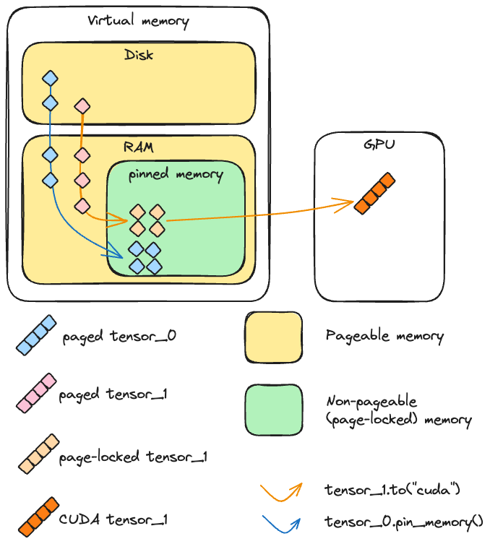

How does TensorRT work.

TensorRT builds an engine off the model.
The way it does it is by initializing a network and inputting the model's parameters into it.
If the model is already in ONNX format, then this step is more straightforward.
Otherwise, one has to populate the network manually by using the conventions of TensorRT for doing that.

Once this step is done, if the engine is to be used later, it can be serialized in the meantime, and deserialized when it will be used.

There are other steps that need to be done, such as allocating buffers, and creating an execution context.

Once done, one can call the function to do inference.

Overall, the process is clear and simple.

Since NVIDIA provides the GPU, you can imagine it will provide useful tools for analyzing its performance and for optimizing the runtime.

As an example, One optimization it provides is that given the optimum input, minimum and maximum tensor dimensions, it selects the kernel that results in the lowest runtime for the given profile.
The selection of the kernel is a command to the GPU, which is enabled through the cuda API's and tensorRT which is designed to communicate with them.

TODO tomorrow:
- Setup benchmark and profiling tools and use with tensorRT inference.
- Try quantization methods on the model and show the results
- One optimization it provides is that given the optimum input, minimum and maximum tensor dimensions, it selects the kernel that results in the lowest runtime for the given profile.
- It supports CUDA asynchronous inference, in which inputs are copied from CPU to GPU, and since it works asynchronously it allows for overlapping of GPU computer, which generally improves inference.
- Another capability, is that when given a batch of inputs, rather than a single one, TensorRT makes use of special kernels and fully connected layers that leverage tensor cores.
- The TensorRT will adapt the engine to the given batch sizes to choose the best algorithms that match the batch sizes, in terms of deploying the inputs onto the GPU.

13.09

Write few pages on deep learning:
-CNN – how tensors are organized
-loss function
-ReLU
-minimizing cost of loss function
-backpropagation
-normalizing data
-stacking examples

Write few pages on GPU:
-optimized for matrix and vector operations
-learning how to write code optimized for gpu's- less for loops more vector operations, show the speedup
-measurements for machine learning - TFLOPS

14.09
Experiment comparing speeds of GPU execution for different command of data transfer by CUDA from CPU to GPU.
Three tensors:
- One pinned (t1)
- One paged (t2)
- One on cuda
Exepriment:
-Perform a copy operation on one tensor, and a cuda operation (multiplication), and see if they happen at the same time or not.
Note: the command here used for copying is "to()"
Some terminology:
H2D – host to device
D2H – device to host
In the context of gpu's, we call the gpu the device, while the host is the cpu.
Both terms refer to the flow of data between the two points.

In the first run, we are copying the paged tensor and running the cuda operation.
The result: while the copy operation is taking place, the cuda operation waits.
Same for pinned memory if we do not start an additional cuda stream.
Only if we pin memory AND start an additional cuda stream (for copying) do we get overlap with another cuda kernel executed on the main stream.

A Pytorch perspective:
Pin_memory() – pytorch command that enables to cast cpu tensors to pinned memory.
This command is blocking on the host's main thread.
Result: sending a pinned memory tensor to gpu (aka casting), is much faster than a pageable tensor, as expected and explained in the introduction.
If we only have a single stream (the main one), then pin_memory() will cause a blocking operation of copying the information to memory.
Therefore, he advantage of using pin_memory is when we can start multiple threads and start the operation in parallel.
For that we have to make use of an argument, called non_blocking.
This argument, as its name implies, designates the operation it is called with to be executed asynchronously.
Note, that in terms of data integrity, when performing asynchronous operations we are more susceptible to operations on the same piece of data happening out of order. Therefore when making asynchronous calls, we need to call the synchronize() command in the end to ensure full and correct completion of the asynchronous operations, before proceeding.
For example, if we are performing a computation on data, asynchronously, we call synchronize to ensure the computation is fully finished before the function that wraps it returns.
This is also important for accurate profiling timing measurements.

When we set non_blocking = true. – ie transferring tensors from cpu to gpu asynchronously.

" Remember that profiling your code and keeping an eye on the memory consumption are essential to optimize resource usage and achieve the best possible performance."'

15.09.2025
Goal: optimize the program for the GPU.
Model: lightweight MLP
Dataset: MNIST digits
Functions:
In mnist_main:
train_epoch(dataloader, model, loss_fn, optimizer, device)
evaluate(dataloader, model, loss_fn, device)
In mnist_inference:
Non-recurrent commands:
    - NeuralNetwork().to(device)
    - Model.eval()
Recurrent commands:
    - Tensor.to(device)
    - Output=model(X)
    - Torch.softmax(output,dim=1)
    - Torch.argmax(probabilities,dim=1).item()

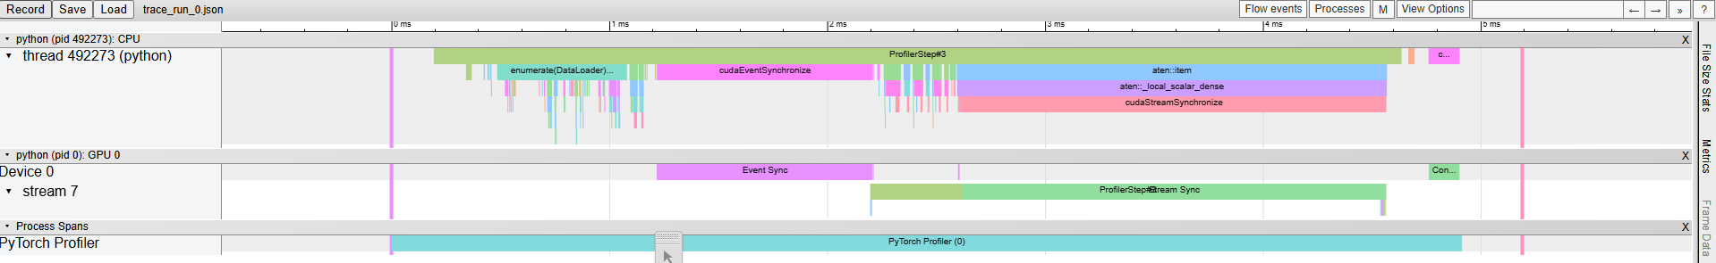
Profiling inference:
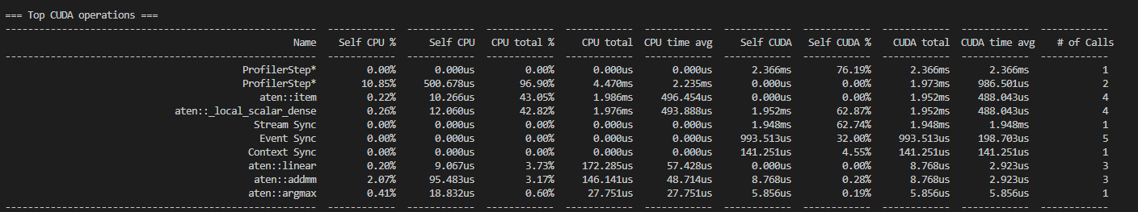
16.09.2025
First profiler run:
Code structure:
- Initialize dataset into dataloader, with pin_memory arg set to True.
- Loop through examples in dataloader
- Sending example to cuda device (with arg non_blocking set to True)
- Calling model(X)
- Calling probabilities (softmax)
- Calling predicted_class (argmax)

Results:
- Order of operations in practice:
- CPU
- Commands repeat in a cycle
- Cycle length (approx): 910 $μs$
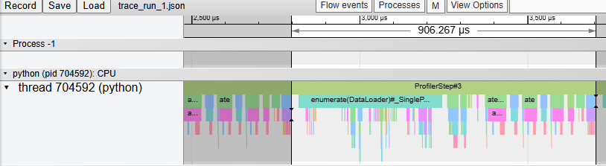
- Breakdown of the cycle:
  - First half: enumerate
    - Command type: copy
    - No GPU activity
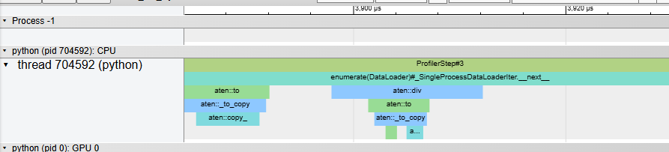
  - Second half: computations
    - Linear, relu, softmax, argmax
    - Calls to GPU – sparse and short, none parallelized.
      - Average exec time for GPU instr < 5 $μs$ , <10 calls per cycle
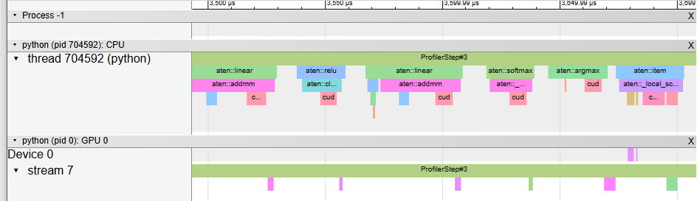

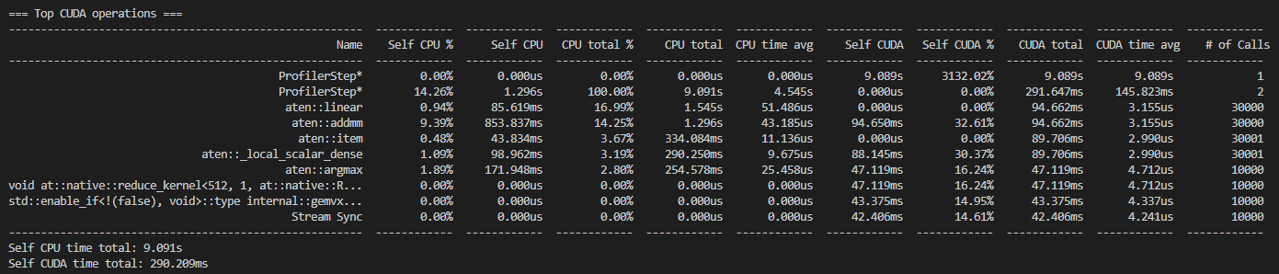
Results summary:

Longest overall CUDA operations (by time and percentage):
ProfilerStep is the reference length (runs 100% of time)
Linear (17% of cpu time)
Addm (14% of cpu time, cuda time says 32% but seems off because it runs much less time – says profiler step for cuda is 3000% which is wrong)
Local_scalar_dense (3% of cpu time)
Argmax (2.8% of cpu time, 16% of gpu time)
Note: Enumerate command (which is high percentage but parallelized does not appear in table)

Inefficiencies:
Most of the load is on the cpu.

Profiler run #2:
Settings:
Pin_memory set to true

Further to dos:
Play with the code more.
Try stuff out on jupyter.
Run comparisons. Define which comparisons to run:
Testing non-blocking (asynchronous) copying vs blocking copying,
Ways to test:
- Use a jupyter notebook to have the flow of the testing in one document
- Comment your code to make it clear what you are going to test
- Use random tensors so you can constantly generate new ones

09/10/2025
After trying to learn the dataset with machine learning algorithms such as linear and logistic regression, we went on to testing the performance of a neural network.
Compared to methods like linear regression, which can only be used to learn, or multiclass where we can learn, there are certain types of data for which it becomes complicated.
For example when we tried to learn concentric circles, the regression algorithms could not "separate" the circles at all. We understood that the type of computation done on the points cannot "learn" the pattern.
In contrast, when we ran a neural network, it performed a convolution. Each neuron in the network is performing a convolution over the data.
And there are multiple layers too. Each layer performs a further computation on the output of the previous layer, treating it as an input.
If configured correctly, it can very effectively learn features of the parameter, which is why it is a highly desirable method for learning spatial data (ie images). This type of neural network is called a convolutional neural network.
The big part of a neural network is that each neuron is the fact that it is composed of neurons that perform a calculation.
סידור של הכתיבה:
- רשת נוירונים בהשוואה לרגרסיה לינארית על דאטאסט שאינו לינארי
- איך בנויה רשת נוירונים
- איך מתאימים רשת נוירונים לדאטאסט
- באיזה רשת השתמשנו לכל דאטאסט ומה היו הביצועים שלה
  - ביצועים עבור מעגלים קונצנטריים לעומת רגרסיה לינארית (כאן נזכיר את החוסר לינאריות)

למידה עמוקה
לאחר שניסינו לעשות למידה של מערך הנתונים באמצעות רגרסיה לינארית ולוגיסטית, עברנו לבחון ביצועי רשתות נוירונים. עבור שיטות כמו רגרסיה לינארית, ישנם סוגים מסוימים של נתונים שעבורם הלמידה איננה אפשרית. לדוגמה, כאשר ניסינו ללמוד דאטא בצורה של זוג מעגלים קונצנטריים, אלגוריתמי הרגרסיה לא יכלו "להפריד" את המעגלים כלל, מכיוון שההפרדה שביניהם איננה לינארית, בעוד שהחישובים ברגרסיה לינארית הינם לינאריים.
רשת נוירונים יכולה לספק את היכולת הזו, על ידי שימוש בפונקציות אקטיבציה לא לינאריות בין השכבות, אליהם נחזור ביתר פירוט בהמשך.
תחילה נתאר בכלליות כיצד רשת נוירונים בנויה, ונתרכז באלמנטים שחשובים להמשך כגון מציאת גודל המודל.
הרשת מורכבת משכבות של נוירונים, שהם יחידות שמכילות פרמטרים ומקבלות קלט משכבות קודמות, עושות עליו חישוב, ומוציאות פלט לנוירונים בשכבות הבאות.
המודל הראשון שבנינו מספריית pytorch היה מודל לינארי. המטרה היתה ללמוד את דאטא סט של מעגלים קונצנטריים שלא צלח עם מודל של רגרסיה לינארית.

לדוגמה, בשכבה לינארית, כל נוירון מקבל את הפלטים מכל הנוירון שבשכבה לפניו , עושה איתם חישוב לינארי, ושולח את התוצאה לכל הנוירונים בשכבה שאחריו.
כמות החישובים שנעשים בכל שכבה נקרא מספר הפרמטרים (model's parameters) באותה שכבה.
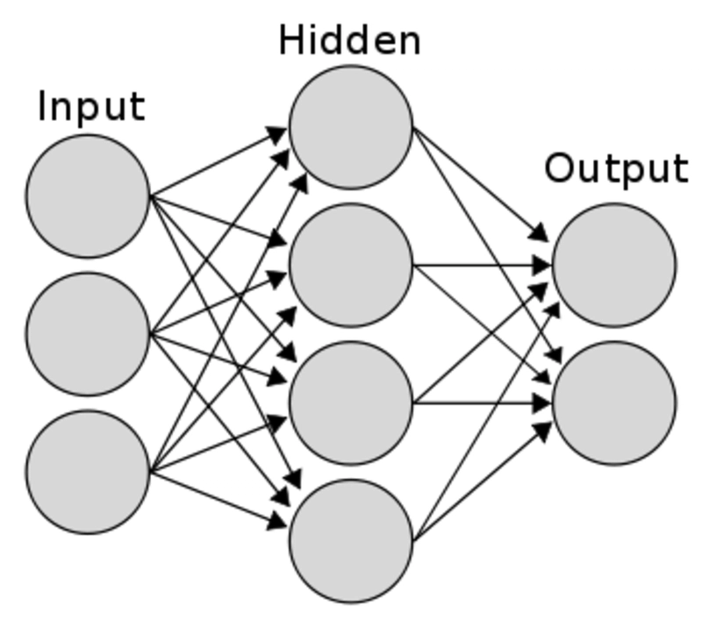
ברשתות לינאריות (ראה איור להלן) החיצים מראים את הזרימה של הפלטים של הנוירונים משכבה לשכבה. ניתן לראות כי מכל נוירון בשכבה מסוימת יוצא חץ לכל נוירון בשכבה שלאחריו.
בשכבה לינארית fully connected)), מספר הפרמטרים עולה לינארית עם מספר הנוירונים.
אם נניח שהשכבות באותו גודל בקירוב, אז אם מגדילים את השכבות ביחד, אז הגידול הוא ריבועי במספר הנוירונים.
עובדה זו קריטית כאשר הקלט שלנו בעל מימדים גדולים וייתכן שאם לא נתאים את המודל נקבל מספר פרמטרים - שמתורגם למספר חישובים שהמעבד עושה - אסטרונומי.
לדוגמה, אם במקום קלט כמו MNIST עם מימד נמוך, אנחנו רוצים לעשות למידה לתמונה ברזולוציה יחסית גבוהה, אז אם נבחר להשתמש ברשת עם שכבות לינאריות בגודל פרופורציונאלי למספר הפיקסלים בתמונה נקבל שכבה עצומה.
לשם כך נעשה שימוש ברשתות קונבולוציה עבור תמונות, שמקטינות משמעותית את מספר הפרמטרים, בכך שחישוב הקונבולוציה לוקח מספר גדול יותר של פיקסלים בבת אחת וכך מקטין את כמות החישוב הנדרשת ללמידה.
עוד יכולת חשובה שרשת נוירונים מספקת, היא למידת דאטא לא לינארי על ידי שימוש בפונקציות אקטיבציה לא לינאריות (Activation functions).
אם היינו משתמשים רק בשכבות לינאריות ללא אקטיבציה, כל הרשת הייתה מתנהגת כמו רגרסיה לינארית אחת גדולה — כלומר, עדיין לא הייתה יכולה ללמוד תבניות לא לינאריות.
כאן נכנסות לפעולה פונקציות כמו ReLU או tanh שמכניסות אי־לינאריות למודל.
ReLU היא שיטה נפוצה שמאפסת את הערכים השליליים של המשקולת, ומשאירה את הערכים החיוביים כפי שהם. פעולה זו הופכת את פונקציית המטרה ללא לינארית, וכך מאפשרת ללמוד תבניות לא לינאריות בדאטא.
מרכיב נוסף ללמידת תבניות מורכבות של קלט, שאלגוריתמי רגרסיה לינארית לא יכולים לתפוס, היא הודות ל שכבות המרובות (Hidden Layers) שברשתות נוירונים.
כל שכבה מוסיפה רובד נוסף של עיבוד למידע. השכבה הראשונה מבצעת טרנספורמציה בסיסית על הנתונים (לדוגמה, שילובים לינאריים של הקואורדינטות), בעוד שהשכבות הבאות מעבדות את הפלט הזה שוב ושוב.
הריבוי של השכבות מאפשר לרשת לבנות ייצוגים מורכבים של הקלט, וכך לתפוס יחסים מתוחכמים כמו שינויי רדיוס במרחב או יחסים מעגליים.
קוונטיזציה
אחת מהשיטות המרכזיות להתמודדות עם זמני הריצה של מודלים, היא קוונטיזציה.
קוונטיזציה היא שיטה שעובדת על הייצוג של המשקולות של מודל.
כידוע, מודל עצמו מורכב בפועל ממשקולות, שנמצאות בייצוג מספרי כלשהו.
ככל שהייצוג יותר מפורט החישובים יותר מדויקים. אבל מצד שני, אותו מספר בייצוג יותר מדויק תופס יותר יחידות מקום בזיכרון.
לכן, בכל פעם שמבוצע חישוב שמשתמש באותה משקולת, אם בייצוג יותר מדויק המשקל תופס 4 יחידות מקום, המעבד יצטרך לשלוף 4 מקומות בזיכרון עד שהוא יוכל לבצע איתם חישוב, לעומת ייצוג פחות מדויק שתופס יחידת מקום אחת.
כיוון שמודל יכול להכיל מספר גדול מאוד של פרמטרים, יש חשיבות גדולה לאופן שבו הם שמורים בזיכרון, ולכן השיטה הזו דורשת תשומת לב כאשר יש צורך להאיץ את ריצת המודל.
כשמדברים על ייצוגים מספרים, המספר שמופיע ליד הייצוג מצייין את מספר הביטים שכל משקולת של המודל תופסת בזיכרון.
לדוגמה, אם המודל ב FP32, משמע שכל משקולות שלו שמורה בייצוג נקודת צפה באורך 32 ביט.
לעומת זאת, אם המודל בFP16, אז הוא גם בייצוג נקודה צפה אבל ב16 ביט. כלומר הוא משתמש במחצית מהביטים לכל פרמטר ביחס לייצוג הקודם.
מבחינת המודל עצמו, זה אומר שהוא תופס חצי מהמשקל.
אבל כאמור, לא מומלץ פשוט לחתוך את כל הפרמטרים, כי ייתכן שנאבד מידע בדרך שיפגע משמעותית במודל.
לכן יש צורך בשיטה מסודרת לבצע את הקוונטיזציה.
כאשר עושים מיפוי על אותו משתנה (לדוג' FP32 ל FP16), המשוואה לכך היא:
$x_{q}=\left(x*S+Z\right)$
-$x$ is the weight without quantization
-$x_{q}$ is the quantized weight
-S is the scaling factor
-Z is the zero point.
כלומר, תחילה עושים scaling לכל ערך בציר המקורי. אז כאשר עוברים מFP32 ל FP16, הערך 2 בייצוג המקורי יהפוך לערך 4 בייצוג החדש. כיוון שאנחנו עושים את זה לכל הערכים, היחס בין הפרמטרים נשמר כפי שהיה במקור, רק שהרזולוציה בין המשקולות קטנה, וכך ייתכן שעבור שני משקולות שהיו שונות במודל המקורי, הן יהיו זהות במודל שעבר קוונטיזציה.
כאשר אנחנו ממפים על שני משתנים שונים, נדרש לעשות פעולה של calibration כדי לעבור בין הייצוגים.
ניתן לעשות זאת על ידי מיפוי אחיד של הערכים מהטווח המקורי לטווח היעד. לדוגמה, כאשר נעשה scaling מ INT16 לINT8, הטווח של INT16 [32767,-32767] ימופה באופן אחיד לטווח [125,-125] של INT8. סוג זה של קליברציה נקרא קליברציה גלובאלית.
שיטה אחרת לוקחת את הערך המקסימלי מהדאטא, ועושה ממנו טווח של הדאטא. שיטה זו נקראת max calibration.
שיטה נוספת שנקראת KL Divergence calibration, והיא עושה שימוש בסימולציות סטטיסטיות כדי לבחור את הscaling factor שמקטין את איבוד המידע.
שיטות מתקדמות של קוונטיזציה במודלים הוכיחו ביצועים מאוד משמעותיים. לדוגמה, שיטה בשם GPTQ הראתה שניתן לעשות קוונטיזציה של מודלי שפה גדולים (175 מיליארד פרמטרים), לייצוג של 4 ביטים בלבד, מה שמאפשר להריץ אותם על GPU יחיד (מסוג מתקדם), עם שיפורי ביצועים פי 4 וכמעט ללא אובדן של דיוק. יש לציין שתוצאה זו מהווה פריצת דרך בתחום, שכן שיטות של קוונטיזציה כגון RTN מראות ירידה משמעותית בביצועים עבור מודלי שפה גדולים.
כאשר עושים קוונטיזציה למודל, ניתן לעשות זאת בצורה איטרטיבית על השכבות של המודל, או על כל ערוץ של המודל. בנוסף, יש גישות שונות לאופטימיזציה של התהליך. גישה אחת מיישמת חישובי שגיאה לטובת קוונטיזציה כבר בשלב האימון של המודל.
גישה אחרת עושה הפרדה בין המשקולות לבין האקטיבציות, ועושה קוונטיזציה רק למשקולות. עוד שיטה מזהה משקולות חשובים לפי מדדים מסוימים במודל, כדון activation magnitude או attention score, ומשאירה את המשקולות הקריטיות בדיוק מלא. לגישות אלו קוראים mixed-precision quantization.
לבסוף יש לקחת בחשבון שתהליך הקוונטיזציה עצמו יכול לקחת זמן, וגם עלול לעשות שינויים בלתי הפיכים למודל, ולכן יש לוודא שהמודל מוכן ומגובה לביצוע התהליך, במיוחד אם זה עוד בשלבי ניסוי.

TODO 21/20/25
-finish summing up inference
-Take code snippets and write explanations - EASY

סיכום על שימוש בפרופיילרים ועבודה עם CUDA
Structure:
Opening question: what are tools and methods to analyze inference in order to optimize it.
Need to have a general understanding of how a gpu works, and the inherent differences it has compared to a cpu. What use cases (such as deep learning), make it especially attractive.
Explain in general asynchronous versus synchronous data transfer, note that cpus do actually have an asynchronous data transfer capacity, that is exploited by the gpu which also can perform parallel computations.
Go over some of the basic function calls and arguments related to data transfer such as to(), with arguments memory pinning,non-blocking.
Transition: Explain that Cuda can provide control over these things (does it have a framework?) Or is it through torch.cuda such as defining a new Stream?Speak about Cuda. Explain that it is a framework that orchestrates this interaction between the cpu and gpu to optimize in general.
Include: discussion about profilers and timers to accurately analyze functions, data flow
Transition sentence: TensorRT implemenets a lot of these things to optimize the inference on a gpu.
Then: Go over briefly the type of features it provides along those lines.
Give some further explanation on TensorRT.
Go over an example article that you read.
Sum up: how will you be using this information towards your goal of optimizing inference.

מבוא לספר פרויקט – חלק של אריאל
עבור שיטות רגרסיה ליניארית, קיימים סוגים של מערכי נתונים שבהם הלמידה אינה אפשרית מבחינה מתמטית, כיוון שהיחסים בין המשתנים אינם ליניאריים. לדוגמה, בעת ניסוי בלמידת מערך נתונים הבנוי משני מעגלים קונצנטריים, אלגוריתמי הרגרסיה לא הצליחו "להפריד" בין המעגלים — משום שההפרדה ביניהם אינה ליניארית, בעוד שמנגנון הרגרסיה מבוסס על חישובים ליניאריים בלבד.
רשת נוירונים, לעומת זאת, מסוגלת להתמודד עם בעיות מסוג זה הודות לשכבות נסתרות שמאפשרות למידה של תכונות ויחסים יותר מורכבים בדאטא, וכן שימוש בפונקציות אקטיבציה לא ליניאריות בין השכבות. פונקציות אלו מאפשרות למודל לבטא יחסים מורכבים יותר בנתונים, כפי שיוסבר בהמשך.
בשלב הראשון, נציג בקצרה את מבנה הרשת ואת המרכיבים המרכזיים הנדרשים להבנת המשך העבודה, בדגש על נושא גודל המודל.
רשת נוירונים מורכבת משכבות של נוירונים מלאכותיים, שכל אחד מהם כולל פרמטרים (משקולות והטיות), מקבל קלט מהשכבות הקודמות, מבצע עליו חישוב, ומעביר את התוצאה לשכבות הבאות.
המודל הראשון שבנינו באמצעות ספריית PyTorch היה מודל ליניארי מלא , שמטרתו הייתה ללמוד את מערך הנתונים של המעגלים הקונצנטריים — מערך שבו מודל הרגרסיה הליניארית נכשל.
בכל שכבה ליניארית, כל נוירון מקבל את הפלט מכל הנוירונים בשכבה הקודמת, מבצע עליהם חישוב ליניארי, ומעביר את התוצאה הלאה.
מספר החישובים - המכונים פרמטרים - בכל שכבה נקבע על פי גודל הקלט והפלט של אותה שכבה.
באיור 1, ניתן לראות כיצד כל נוירון מחובר לכל הנוירונים בשכבה הבאה, מה שממחיש את העלייה הליניארית במספר הפרמטרים בהתאם לגודל השכבות.
כאשר מגדילים את מספר הנוירונים בשכבות, ובפרט כאשר השכבות הן באותו סדר גודל, כמות הפרמטרים — ובהתאם גם כמות החישובים שהמעבד נדרש לבצע — גדלה ריבועית.
איור 1: רשת נוירונים לינארית
עובדה זו קריטית במיוחד כאשר הקלט בעל מימדים גבוהים.
לדוגמה, במעבר מתמונות פשוטות כמו Digit MNISTלתמונות ברזולוציה גבוהה, שימוש בשכבות ליניאריות בגודל פרופורציונלי למספר הפיקסלים ייצור מודל עצום ובלתי ישים חישובית.
במקרים כאלה נעשה שימוש ברשתות קונבולוציה – convolutional neural networks -- המקטינות משמעותית את מספר הפרמטרים על ידי הפעלת חישוב קונבולוציוני מקומי, שלוקח בחשבון קבוצות של פיקסלים בבת אחת. כך נחסכת כמות גדולה של חישוב תוך שמירה על יכולת למידה של תבניות חזותיות מורכבות.
מרכיב מרכזי נוסף בלמידה עמוקה שצוין לעיל הוא השימוש בפונקציות אקטיבציה לא ליניאריות. אילו היינו משתמשים רק בשכבות ליניאריות ללא פונקציות אקטיבציה, כל הרשת הייתה מתנהגת למעשה כרגרסיה ליניארית אחת גדולה — ולכן לא הייתה מסוגלת ללמוד תבניות לא ליניאריות.
פונקציות כמו ReLU וtanh מאפשרות להכניס אי-ליניאריות לרשת.
ReLU, למשל, מאפסת את הערכים השליליים של הפלט ומשאירה את הערכים החיוביים ללא שינוי. פעולה פשוטה זו שוברת את הליניאריות של המודל ומאפשרת לרשת לזהות דפוסים מורכבים בנתונים.
בנוסף, עומק הרשת — כלומר מספר השכבות החבויות— מוסיף לרשת יכולת לעבד מידע בצורה היררכית.
השכבה הראשונה מבצעת טרנספורמציות בסיסיות על הנתונים, כמו שילובים ליניאריים של קואורדינטות, בעוד שהשכבות הבאות בונות על פלט זה ומזקקות ממנו ייצוגים מופשטים יותר ויותר.
כך נוצרת למידה הדרגתית של ייצוגים — מתכונות פשוטות ועד לתבניות מרחביות מורכבות, כגון שינויי רדיוס או יחסים מעגליים — יכולת שלמודלים ליניאריים אין.

אחת מן השיטות המרכזיות להאצת זמני הריצה של מודלים נוירוניים היא קוונטיזציה.
שיטה זו מתמקדת באופן שבו נשמרים ומיוצגים המשקולות והאקטיבציות של המודל ברמה המספרית.
באופן כללי, כל מודל למידת מכונה מורכב ממשקולות בעלות ייצוג מספרי. ככל שהייצוג מפורט יותר — כלומר, נעשה שימוש ביותר ביטים לכל ערך — כך הדיוק החישובי עולה, אך גם צריכת הזיכרון והמשאבים החישוביים גדלה.
אם נבחן משקולת במודל, בכל פעם שמבוצע חישוב שמשתמש באותה משקולת, אם בייצוג יותר מדויק המשקל תופס 4 יחידות מקום, המעבד יצטרך לשלוף 4 מקומות בזיכרון עד שהוא יוכל לבצע איתם חישוב, לעומת ייצוג פחות מדויק שתופס יחידת מקום אחת.
לכן, קיים יחס הפוך בין דיוק הייצוג לבין יעילות הביצוע.
היות ומודל נוטה להכיל מספר גדול מאוד של פרמטרים, יש חשיבות גדולה לאופן שבו הם שמורים בזיכרון, ולכן השיטה הזו דורשת תשומת לב כאשר יש צורך להאיץ את ריצת המודל.
במקרים שבהם למודל יש מיליארדי פרמטרים, הבדל זה מתורגם לחיסכון עצום בזמן ובאנרגיה.
קוונטיזציה מגדירה מחדש את ייצוג הנתונים — לרוב באמצעות מיפוי ערכים רציפים למרחב בדיד ומצומצם יותר של ביטים.
לדוגמה, מעבר מ־FP32 ל־FP16 משמעו שימוש במחצית מכמות הביטים לכל פרמטר, ובכך מתקבלת הפחתה של כ־50% בשימוש בזיכרון.
עם זאת, הפחתה גסה עלולה לגרום לאובדן מידע ולירידה בדיוק המודל.
לכן, הקוונטיזציה מתבצעת לפי שיטות מיפוי מבוקרות, כגון:
$$x_{q}=x×S+Z$$
כאשר
- $x$ הוא הערך המקורי,
- ${ x}_{q}$הוא הערך המקוונט,
- $S$הוא מקדם הסקיילינג (Scaling Factor) ,
- $Z$הוא נקודת האפס (Zero Point) .
כלומר, תחילה עושים סקיילינג לכל ערך בציר המקורי. אז כאשר עוברים מFP32 ל FP16 הערך 2 בייצוג המקורי יהפוך לערך 4 בייצוג החדש. כיוון שאנחנו עושים את זה לכל הערכים, היחס בין הפרמטרים נשמר כפי שהיה במקור, רק שהרזולוציה בין המשקולות קטנה, וכך ייתכן שעבור שני משקולות שהיו שונות במודל המקורי, הן יהיו זהות במודל שעבר קוונטיזציה.
באופן הזה, הטווח של INT16 [32767,-32767] ימופה באופן אחיד לטווח [125,-125] של INT8 .
המטרה היא לשמור על היחסים היחסיים בין הפרמטרים, גם כאשר הרזולוציה המספרית יורדת.
-כאשר מבצעים מיפוי בין שני סוגי נתונים שונים, כגון FP32 ל-INT8, יש לקבוע גורם קנה מידה מתאים למיפוי הטווח של FP32 ל-INT8. טכניקה זו ידועה בשם כיול.
$$s = \frac{2^{b}-1}{α - β}$$

קיימות מספר גישות נוספות של קליברציה לכך:
- Global calibration – מיפוי אחיד של כלל הערכים מהטווח המקורי לטווח החדש.
- Max calibration -- התאמת הטווח לפי הערך המקסימלי בנתונים.
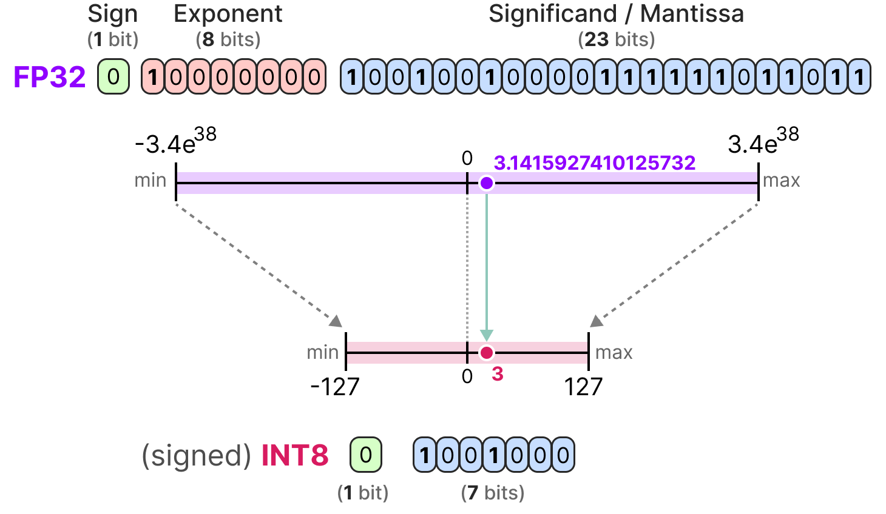
- Percentile calibration במקום לבחור את הערך המקסימלי הגלובלי, שעשוי להיות בקצה התחתון של הנתונים, פעולה זו בוחרת אחוזון המייצג את הערכים החשובים, וקובעת ממנו את המקסימום. האחוזון האופטימלי הוא בדרך כלל 99.99% או 99.999%.
איור 2: קוונטיזציה
בשנים האחרונות פותחו שיטות מתקדמות המיישמות קוונטיזציה במודלים גדולים במיוחד.
כך לדוגמה , GPTQ מאפשרת לקוונטז מודלים בהיקף של 175 מיליארד פרמטרים לייצוג של 4 ביטים בלבד, תוך שמירה כמעט מלאה על הדיוק המקורי ושיפור ביצועים של פי ארבעה בהרצת האינפרנס על GPU יחיד.
מנגד, שיטות פשוטות יותר כמו RTN נוטות לגרום לפגיעה ניכרת בביצועים במודלים דומים.
תהליך הקוונטיזציה יכול להתבצע במספר רמות:
- על כלל שכבות המודל בו־זמנית.
- ברמת הערוץ (Per-channel quantization).
- או תוך הפרדה בין משקולות לאקטיבציות.
כמו כן, קיימות גישות מתקדמות של Mixed-Precision Quantization, בהן נשמרת דיוק מלא רק עבור משקולות קריטיות בהתאם למדדים כמו Activation Magnitude או Attention Score , בעוד שהיתר מקוונטזות בדיוק מופחת.
חשוב לציין שתהליך הקוונטיזציה עצמו עשוי להיות ארוך ואף בלתי הפיך.
לפיכך, נהוג לבצעו רק לאחר שהמודל בשל, מגובה, ונבדק היטב, במיוחד כאשר מדובר בשלב ניסיוני של הפיתוח.

כאשר אנו שואפים לשפר את ביצועי האינפרנס של מודלים של למידה עמוקה, נדרש להבין אילו כלים ושיטות מאפשרים למדוד, לנתח ולבצע אופטימיזציה לתהליך. אחד המרכיבים המרכזיים הוא המעבד הגרפי (GPU), אשר מתוכנן לביצוע מקבילי של חישובים, בניגוד למעבד המרכזי (CPU) המבצע לרוב חישובים סדרתיים.
ההבדלים הארכיטקטוניים בין CPU ל־GPU הופכים את ה־GPU לאטרקטיבי במיוחד למשימות כמו למידה עמוקה — שבהן נדרשות פעולות חוזרות על מטריצות גדולות או טנזורים, וניתן להריץ חישובים רבים במקביל על ליבות (CUDA cores) רבות.
אחת התכונות החשובות של GPU היא יכולתו לבצע העברת נתונים אסינכרונית בין הזיכרון של ה־CPU לזה של ה־GPU . בשונה מהעברה סינכרונית שבה התוכנית ממתינה לסיום הפעולה, העברה אסינכרונית מאפשרת לתהליך אחר להמשיך לרוץ במקביל. גם מעבדי CPU תומכים במידה מסוימת באסינכרוניות, אך ב־ GPU הדבר מנוצל באופן נרחב יותר — במיוחד מאחר והוא מסוגל לבצע חישובים מקביליים במקביל להעברות נתונים.
במסגרת פיתוח ב־PyTorch לדוגמה, ניתן להגדיר העברה של טנזורים אל הזיכרון הגרפי באמצעות הפונקציה to(), ולציין פרמטרים כמו non-blocking או שימוש ב־ pinned memory כדי לשפר את ביצועי ההעברה.
השליטה בתזמון ההעברות והחישובים מתבצעת לרוב באמצעות CUDA ( סביבת פיתוח של חברת NVIDIA ).
CUDAמספקת ממשק המאפשר למתכנת לשלוט בתקשורת בין ה־ CPU ל־ GPU לנהל זרמי עבודה מקבילי (Streams) , להפעיל קריאות ליבות (Kernels), ולבצע אופטימיזציה לתזמון ולשימוש במשאבים.
באמצעות CUDA ניתן ליצור מספר זרמים (streams) כדי להריץ משימות שונות במקביל — לדוגמה, העברת נתונים תוך כדי ביצוע חישוב, וכך למקסם את השימוש במשאבי ה־GPU.
בשל המורכבות הגבוהה של תזמון ועומסי עבודה, נעשה שימוש בכלים לניתוח ביצועים (Profilers) כדי להבין היכן מתבזבז זמן החישוב או ההעברה. כלים כמו NVIDIA Nsight Systems, או הפרופיילר המובנה ב־PyTorch (torch.profiler) מאפשרים למדוד את זמני ההרצה של פונקציות ספציפיות, לזהות צווארי בקבוק, ולנתח את השימוש בזיכרון ובמעבד.
בנוסף לפרופיילרים, נעשה לעיתים שימוש ב־timers פנימיים למשל (torch.cuda.Event) כדי למדוד במדויק את משך הזמן בין שלבי החישוב השונים.
כלים מתקדמים יותר, כמוTensorRT , לוקחים את העקרונות הללו צעד קדימה. TensorRT זו ספרייה של NVIDIA המיועדת לביצוע אופטימיזציה של אינפרנס על .GPU היא מנתחת את גרף החישוב של המודל, מאחדת קריאות Kernel (kernel fusion), ממירה ייצוגים מספריים (כמו FP32 ל־INT8 או (FP16 ומבצעת התאמות אוטומטיות לשם הקטנת latency והגדלת קצב העיבוד (throughput).
TensorRT משתמשת בשיטות דומות לאלו שתוארו קודם, כגון ניהול זיכרון יעיל, קוונטיזציה, ואופטימיזציה של זרימות עבודה פנימיות — אך בצורה אוטומטית ומבוססת פרופיילינג.
במאמרים עדכניים הודגם כיצד TensorRT הצליחה לשפר משמעותית את זמני האינפרנס של מודלים עמוקים מבלי לפגוע בדיוק, בעיקר כאשר נעשה שימוש ב־mixed precision ובkernel fusion. בפרויקט הנוכחי, נשתמש בתובנות ובכלים הללו כדי לזהות ולשפר את מרכיבי האינפרנס של המודל שלנו — בין אם באמצעות פרופיילרים, קוונטיזציה, או אופטימיזציה מבוססת TensorRT — במטרה להגיע לשיפור מדיד בזמן הריצה וביעילות החישובית של המערכת.

A Comprehensive Study on Quantization Techniques for Large Language Models
GPTQ: Accurate Post-Training Quantization for Generative Pre-trained Transformers
A guide on good usage of non_blocking and pin_memory() in PyTorch
Speeding Up Deep Learning Inference Using NVIDIA TensorRT(

